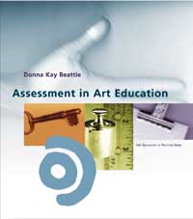
Assessment Book Suggestions:
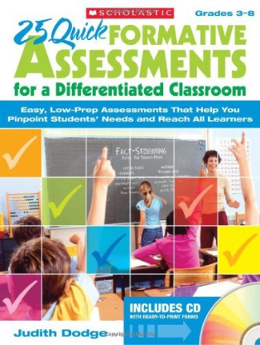
Assessment in Art Education
by Donna Kay Beattie

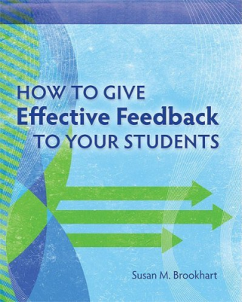
25 Quick Formative Assessments for a Differentiated Classroom
by Judith Dodge

How to Give Effective Feedback to Your Students
by Susan M. Brookhart
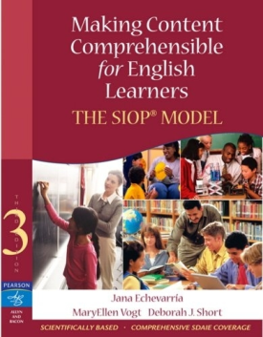
Making Content Comprehensible for English Learners: The SIOP Model
by Jana Echevarria, MaryEllen Vogt, and Deborah J. Short.
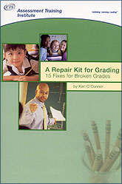

A Repair Kit for Grading: 15 Fixes for Broken Grades
by Ken O’Connor
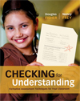
Checking for Understanding: Formative Assessment Techniques for Your Classroom by Douglas Fisher and Nancy Frey

